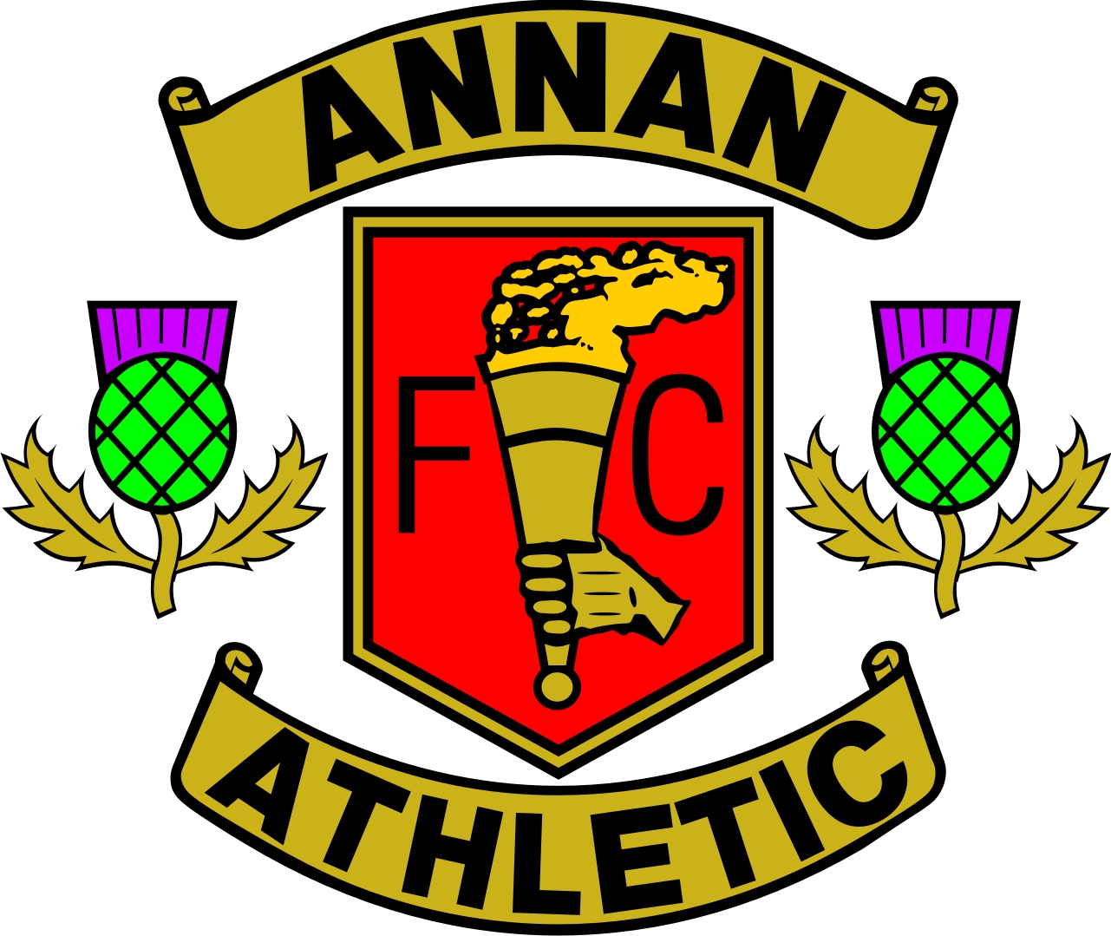

Galabank, North Street, Annan DG12 5DQ
Tel and Fax: 01461 204108 www.AnnanAthleticFC.com
REGISTRATION / PARENTAL CONSENT /
MEDICAL TREATMENT / PHOTOGRAPHY & SOCIAL MEDIA

Player Registration

Name:
Address:
Postcode: |  | E:Mail:
Gender: |  | Date of Birth:
School Year: |  | School:
Tel (day): |  | Tel (eve):
Mobile: |  | Reg Fee Paid: | Yes | No
Emergency Contact Details: | Name:  Address:  Telephone No / Mobile:
Medical Conditions:
Please advise us of any other issues you think we should be aware of:

It is the responsibility of the parent / guardian to inform Annan Athletic F.C. in writing if any details included on this form change.

Please note that Annan Athletic FC have a Child Protection Policy & Officers. For further information or to
discuss any issues please contact Allan Gribbon or Susan Bryson – contact details on Club Website.

PTO:

NAME: ________________________________

Parental/Guardian Consent

By returning this completed form I agree to the child named above taking part in the normal training sessions / games of the club. Unless unaccompanied by myself I agree that he / she will be under the authority of the coach. I have read the code of conduct for parents / spectators and agree to abide by those whilst in the care of the club. I will discuss the player code of conduct with the child named above and I understand that if I or the named child does not follow the code of conduct, action may be taken by the Club.

Parent/Guardian Name: _______________________________

Signature: ___________________________________________ Date: _____________________

Medical Treatment

If at any time during a club training session/game your child requires first aid I give permission to a first aid trained coach to administer this. If your child requires urgent medical treatment (provided I cannot be contacted) I give my permission to a doctor or surgeon to make any medical decisions necessary including administering an anaesthetic.

Parent/Guardian Name: _______________________________

Signature: ___________________________________________ Date: _____________________

Photography / Social Media

From time to time the club may wish to take pictures for promotional use in local, regional or national media to promote the work of the club this includes the club website, newspapers and social media. Any photographs taken will be used solely for promotional purposes. Please sign below to indicate your agreement for pictures / filming to be taken for the above reasons.

Parent/Guardian Name: _______________________________

Signature: ___________________________________________ Date: _____________________

PLEASE NOTE THAT THOSE AGED UNDER 18 YEARS OF AGE WHO DO NOT HAVE A COMPLETED / SIGNED CONSENT FORM WILL NOT BE ALLOWED TO PARTICIPATE.

